|  |  |  |
| --- | --- | --- |
| E | Digit Printing | Time Limit:  **1 sec** |
| Setter: Sifat Siddiqi Shishir | Memory Limit:  **512 MB** |

You will be given two numbers and an operation to do with them. You just need to print the output of the numbers after doing the operation.

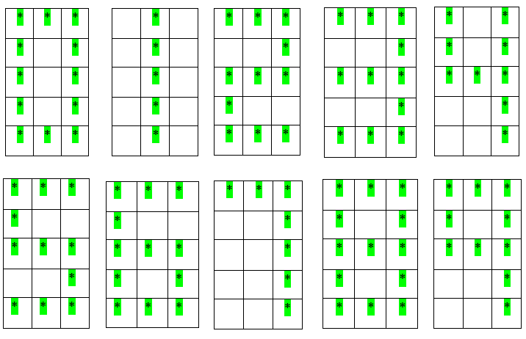

The digits you need to print are in the above image. Each digit is a **3 x 5** matrix filled with asterisk **(*)** sign. Print the final absolute value of your output separated by a space for each digit. See sample I/O for better understanding.

**Input:**

First line of input will be **T** the number of test cases **(<= 15)**. Each test case will contain a line having two integers **X** & **Y** and a character **C**, where **(-100000 <= X, Y <= 100000)** & **(‘+’, ‘-’, ‘*’)** denoting the addition (‘+’), subtraction (‘-’), multiplication (‘*’) operation.

**Output:**

Output each case like following format: **Case #x:** where **x** is the number of the case. And in a new line print absolute value of the desired output separated by space for each digit. Print a blank line after each case.

**Sample I/O:**

|  |  |
| --- | --- |
| Sample Input | Sample Output |
| 2  5 + 5  9 * 9 | Case #1:  * ***  * * *  * * *  * * *  * ***  Case #2:  *** *  * * *  *** *  * * *  *** * |